### **MOBILE SPATIAL EPIDEMIOLOGY DATA CAPTURE**

Mobile Global Positioning System (GPS) receivers such as phones can be used to generate real time public health data. The user testing analysis of the Esri collector based on built-in functions showed its potential in spatial and attributes capture for 2017 – 2018 cholera outbreaks in Karonga district.

Spatial data dimension analysis, shows that Esri collector can capture coordinates up to the average minimum accuracy of 3.3m. The collector demonstrates its capability in mapping waypoints for 2017 -2018 cholera case in Karonga district (figure 1).

The configuration process indicated its attractive features such as collect a new feature icon, measure distance and area functions, search bar, bookmarks and others. The configuration process shows that the file geodatabase for Esri collector built in ArcMap 10.6 can be created using different domain name with the description extension. The domain name can be set in different properties by choosing appropriate field type such as text, short integer, long integer, float, double and date. The geodatabase for Esri collector can also be set with unique coded values. The configuration process demonstrates that after creating all required attribute domains, feature classes can be added to the geodatabase. The application demonstrated its online and offline field data acquisition and online data syncing into ArcGIS geo-server.

The configuration process of Esri collector allows photo-tagged data capture and data syncing. Field observations show that texts for the collector were readable, can be in upper or lower case and allows scrolling of text, numeric and date option. The application works with an authority permitted by Esri through ArcGIS online organization account. Cholera cases for 2017 – 2018 were collected by Esri collector using *mulanje1* account for UNICEF Malawi.

Field observations show that collector application is user friendly with easy to understand, operate and navigate. It is reliable application with easy to remember its organization link, speed download, data sync function and its measuring efficiency. The collector allows for data update such as editing. Figure 1 shows the application’s configuration process, spatial data capture capability and mapped waypoints.

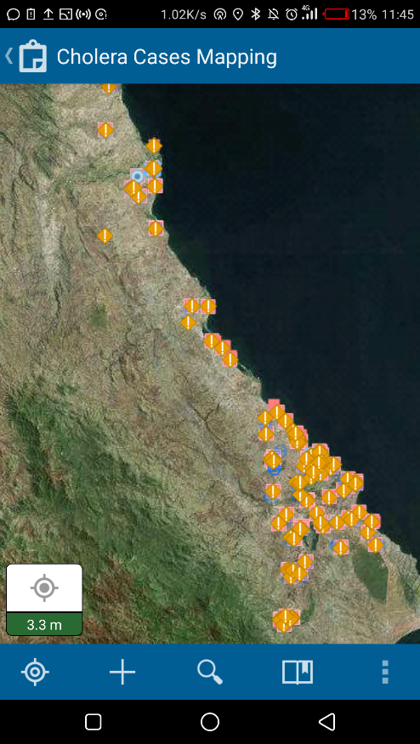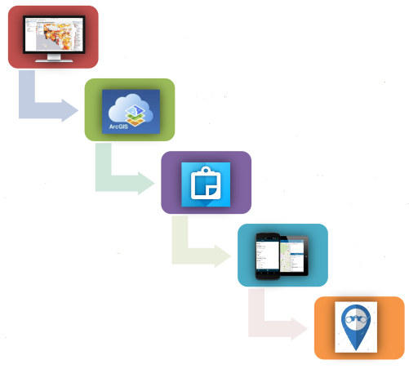

* Desktop ArcGIS for project design
* Publish project on ArcGIS online
* Access via ArcGIS collector app.
* Collect data in the field
* Remotely monitor data collection in real time

**Source: Suresh, et al., 2018**

**Figure 1: Esri collector’s configuration process, spatial data capture capability and mapped waypoints**